**Learning Objectives**

* To learn about functions of a browser.

**Learning Contents**

* A browser can be treated as a document viewer and the document mentioned here refers to web page.
* You are now reading a web page compiled in HTML with a browser.
* You can visit a web page and use network applications through a browser.
* HTML document
  + A web page is an HTML document. It is just like other documents in the computer except that it is a text file with the extension .html.
  + There might be different types of file in our computers:
    - .jpg are image files;
    - .mp3 are music files;
    - .avi are music files;
    - .doc are Word documents;
    - .xls are Excel documents.
  + All these types of documents can be opened with specific programs. Some of the programs can only open files while some of them can not only open files but create and modify files. For example:
    - NetEase Cloud Music can open music documents in .mp3 format.
    - Microsoft Word can not only open a document in .doc format, but create or edit a document in .doc format.
    - PotPlayer can open video documents in .avi format.
  + The program used to open an HTML document is a browser, e.g. IE or Chrome. The program used to create an HTML document is a text editor, e.g. VS Code or Sublime Text.
* Common browsers:

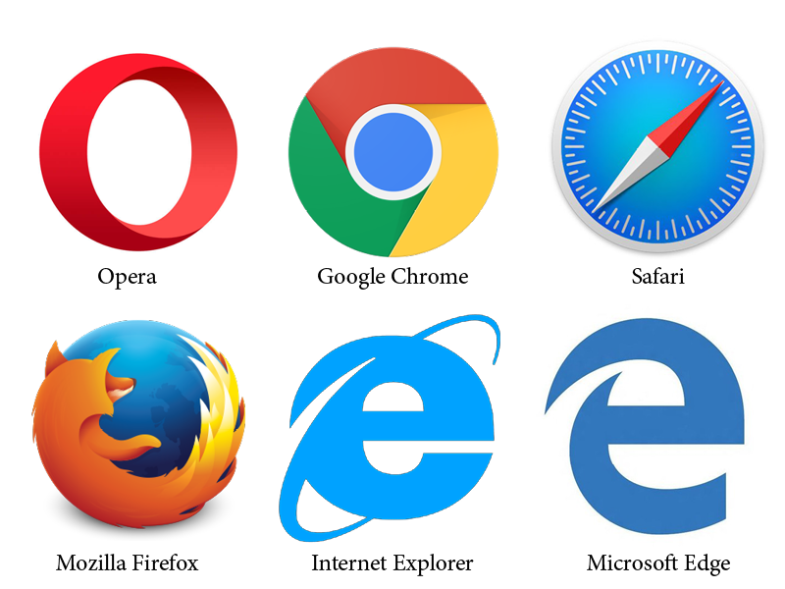

**Recommended Resources**

* Web Page Browser (<https://en.wikipedia.org/wiki/Web_browser>)
* Browser (<https://baike.baidu.com/item/%E6%B5%8F%E8%A7%88%E5%99%A8>)